**EAST WEST UNIVERSITY**

**RFID Based Automated Toll Collection System**

**Submitted By**

Md. Fokhor Uddin

ID: 2014-2-60-054

Md. Imtiaz Hossain

ID: 2014-2-60-038

A.S.F Rabby Pathan

ID: 2014-2-60-074

**Supervised By**

Dr. Anisur Rahman

Assistant Professor

Department of Computer Science & Engineering

East West University

The project has been submitted to the Department of the Computer Science & Engineering at East West University in the partial fulfillment of the requirement for the degree of Bachelor of Science in Computer Science and Engineering**.**

September, 2018

**Declarations**

The project has been submitted to the Department of the Computer Science & Engineering, East West University in the partial fulfillment of the requirement for the degree of Bachelor of Science in Computer Science & Engineering. We hereby, declare that this project has not been submitted elsewhere for the requirement of any degree or diploma or any other purposes.

Signature of the students

…………………………..

(Md. Fokhor Uddin)

(ID: 2014-2-60-054)

…………………………….

(Md. Imtiaz Hossain)

(ID: 2014-2-60-038)

…………………………….

(A.S.F Rabby Pathan)

(ID: 2014-2-60-074)

i

**Letter of Acceptance**

This project is entitled “Automated Toll Collection System” submitted by: Md. Fokhor Uddin ID: 2014-2-60-054, Md. Imtiaz Hossain ID: 2014-2-60-038 and A.S.F Rabby Pathan ID: 2014-2-60-074 to the department of Computer Science & Engineering, East West University, Dhaka, Bangladesh is accepted as satisfactory for partial fulfillment of the requirement for the degree of Bachelor of Science in Computer Science & Engineering on August 2018.

Supervisor

………………………………………….

Dr. Anisur Rahman

Assistant Professor

Department of Computer Science & Engineering East West University, Dhaka, Bangladesh.

Chairperson

………………………………………….

Dr. Ahmed Wasif Reza

Chairperson and Associate Professor

Department of Computer Science & Engineering East West University, Dhaka, Bangladesh.

ii

**Abstract**

Due to the expansion of the vehicle transportation system, Jam on toll collection booth is common nowadays & become a serious problem in recent years. Because of increase lots of vehicle and toll are collected by human, lots of time waste is occurring here, so it is essential to design & implement a modern system, which can monitor & collect toll from these vehicles automatically. A system that is able to sense the vehicle and collect toll from the vehicle automatically. So, human toll collector is not needed here and vehicle don’t need to waste time by waiting on toll booth because it will collect toll faster than human toll collector.

In our project, we have showed it by interfacing Arduino Uno, Arduino Mega, Ethernet Shield and Camera. When a vehicle arrives, if the car owner has registered RFID card and sufficient balance on his RFID card, he is free to go his card number will be saved in the database. Even though the member does not have sufficient balance he will be allowed to go. There will be some negative value in his balance. After a while the bill can be send to his house. Again the car owner may not have any registered card. On this case a Camera is set take car photo which will also be captured automatically, and will be stored in a fixed folder that will also be shown in our website.

For database showing we used PHP language. On this site, we insert a new registered car, details about the car, all the car logs means when did it go, recharge the balance also we can see all the unauthorized and unregistered cars picture with its passing time which will help to find the car.

In this system one car do not need to stop the car to give the toll money. It will automatically cut down from owners account balance. All the necessary details will be found in the website. As the system is fully automated, there is no need for a staff to operate this system.

The system is collecting toll money without stopping a car. So there will be no traffic jam due to the collection of the toll money.

iii

**Acknowledgement**

First of all, we would like to thank almighty Allah for giving us strength, patience and knowledge to complete this project work.

Our most heartfelt gratitude goes to our beloved parents for their endless support, continuous inspiration, great contribution and perfect guidance from the beginning to end.

We would like to express our sincere gratitude to our supervisor Dr. Anisur Rahman for the continuous support, for his patience, motivation, and immense knowledge. His guidance helped us in all the time of our work. We could not have imagined having a better supervisor and mentor for this project.

We would like to express our sincere gratefulness to the faculty members of the Department of Computer Science and Engineering (CSE), East West University, Bangladesh for their friendly attitude and enthusiastic support that has given us and helped us with their feedback.

In addition, we would like to thank our friends and seniors for their motivation, stimulation, feedback, cooperation and of course friendship.

iv

**TABLE OF CONTENTS**

**Title**

Declaration

Letter of Acceptance

Abstract

Acknowledgement

Table of Contents

**Chapter 01**

**Introduction**

1 Introduction

|  |  |
| --- | --- |
| 1.1 | Motivation |
| 1.2 | Objective |
| 1.3 | Contribution |
| 1.4 | Outline |

**Chapter 02**

**Background**

|  |  |
| --- | --- |
| 2.1 | What is Arduino? |
| 2.2 | Why Arduino? |
| 2.3 | What can we do with Arduino? |
| 2.4 | What We Need for a Working System? |
| 2.5 | Installing the Software |
| 2.6 | Arduino Programming Language |
| 2.7 | Common Coding Errors |

**Chapter 03**

**Description of the Hardware System**

|  |  |
| --- | --- |
| 3.1 | Arduino Uno |
| 3.2 | Arduino Mega |
| 3.3 | Arduino Ethernet Shield |
| 3.4 | RFID (RC522) sensor and card |
| 3.5 | Camera OV7670 |
| 3.6 | LCD Display 16x2 |
| 3.7 | IIC/I2C Serial Interface Module |
| 3.8 | Sonar Sensor |
| 3.9 | Buzzer |

v

**Page no**

i

ii

iii

iv

v-viii

**01-04**

01

02

03

04

04

**05-08**

05

06

07

07

07

08

08

**9-43**

9

16

20

26

32

35

37

38

40

|  |  |  |
| --- | --- | --- |
| **Chapter 04** | |  |
| **Description of the Software System** | | **44-54** |
| 4.1 | Introduction | 44 |
| 4.2 | Structure | 45 |
| 4.3 | Variable Declaration | 46 |
| 4.4 | Arithmetic Operator | 46 |
| 4.5 | Compound Operator | 47 |
| 4.6 | Boolean Operator | 48 |
| 4.7 | pinMode(pin,mode) | 49 |
| 4.8 | digitalWrite(pin,value) | 50 |
| 4.9 | delay(ms) | 51 |
| 4.10 | Serial.begin(speed) | 51 |
| 4.11 | Serial.println(val) | 52 |
| 4.12 | Database Overview | 53 |
| **Chapter 05** | |  |
| **Conclusion** | | **55-56** |
| 5.1 | Future Work | 56 |
| **References** | | **57-58** |
| **Appendix** | |  |
| **Code** |  | **59-63** |

vi

**List of Figures:**

|  |  |  |  |
| --- | --- | --- | --- |
| Fig 1.1 | Toll collection booth at kanchpur meghna | 03 |  |
|  | bridges and jam on toll collection booth |  |  |
| Fig 3.1 | Arduino Uno | 11 |  |
| Fig 3.2 | Arduino Mega | 17 |  |
| Fig 3.3 | Arduino Ethernet Shield | 21 |  |
| Fig 3.4 | RFID-RC522 | 27 |  |
| Fig 3.5 | Simplified RC522 Block diagram | 30 |  |
| Fig 3.6 | RFID tag 1 | 31 |  |
| Fig 3.7 | RFID tag 2 | 31 |  |
| Fig 3.8 | Camera OV7670 | 32 |  |
| Fig 3.9 | 16x2 LCD Display | 35 |  |
| Fig 3.10 | Pinout Diagram | 36 |  |
| Fig 3.11 | Schematic diagram of Arduino Uno & LCD Display | 37 |  |
| Fig 3.12 | IIC/I2C Serial Interface Module | 38 |  |
| Fig 3.13 | Sonar sensor | 39 |  |
| Fig 3.14 | Buzzer | 40 |  |
| Fig 3.15 | Output 1 | 41 |  |
| Fig 3.16 | Output2 | 41 |  |
| Fig 3.17 | Output3 | 41 |  |
| Fig 3.18 | Hardware Connections | 42 |  |
| Fig 3.19 | Prototype of the toll system | 43 |  |
| Fig 3.20 | Prototype of the toll system (Road View) | 43 |  |
| Fig 4.1 | Home View | 53 |  |
| Fig 4.2 | All car logs | 53 |  |
| Fig 4.2 | Unauthorized car | 54 |  |

vii

**List of Tables:**

|  |  |
| --- | --- |
| Table 1.1 Yearly Bi-directional Flow Variation on Meghna-Gomoti | 02 |
| Bridge, 2009-2017 |  |

viii

**Chapter 1**

**Introduction**

Since Bangladesh is developing day by day, its road and transport system is also developing and as a result, the number of vehicle in Bangladesh is increasing rapidly. The bearing of human and product through vehicle is also raising because people are now using vehicles for many purposes like travels, business etc. as affordable, comfortable and use road for bearing business product are also very popular for its low cost. As the number of vehicles in Bangladesh is raising day by day, the pressure on toll collection booth is also raising. It is a common matter of huge jam on toll collection booth nowadays. Because, toll is collected by manually and it waste some time, as a result our valuable time are lost and it hampers the productivity of our country. So, we have developed a system where toll collection will be automated and the car just have to have a registered RFID card and sufficient amount on his balance. When a car arrives the first sonar sensor will notice it and if it has no RFID, the buzzer will give alarm and LCD will show a message to go left for manual pay. But, if it has valid RFID card and scan on RFID sensor, it will deduct toll amount and allow this car to go by open barrier created with stepper motor and second sonar sensor will notice the left of that car and close the barrier. To achieve this purpose, the system is controlled by a micro controller which is Arduino Uno R3. Managing toll booths is a very complicated task but using our system that automates the entire toll collection process of toll booth, it will reduce the consumption of time.

1

**1.1 Motivation**

The uses of vehicles in Bangladesh are increasing day by day because of the affordable cost on transport; so, people are more frequently uses vehicle for travel and business purpose. But, the management of this huge number of car on toll booth is very challenging for human toll collector. He has to stop the car, collect toll and let the car to go which is very much time consuming and create jam if the number of car in toll booth is huge. What if a system can provide toll collection in a fast way where any human toll collector don't needed.

|  |  |
| --- | --- |
| **Year** | **Yearly Volume** |
| 2009 | 3,210,410 |
| 2010 | 4,313,837 |
| 2011 | 4,732,949 |
| 2012 | 5,632,798 |
| 2013 | 5,915,501 |
| 2014 | 6,045,819 |
| 2015 | 6,239,174 |
| 2016 | 6,464,564 |
| 2017 | 7,018,983 |

**Table 1.1:** Yearly Bi-directional Flow Variation on Meghna-Gomoti Bridge, 2009-2017 [19]

For sample, if we see the above table, we can see the yearly Bi-directional Flow Variation of year 2009-2017 on Meghna-Gomoti Bridge, one of the major Bridge situated in

2

Dhaka Chittagong Highway, we can see that the load of vehicles is raising year by year, as a result load on toll collection booth also be raised in recent years and if we still remain on human-based toll collection system, traffic problem on toll collection booth will not reduce.

So, we can introduce automated toll collection system where don't need any human toll collector. we can use an automated system that can collect toll by RFID card which will be previously recharged and the barrier also be automated. There have RFID sensor, which will sense the RFID card, deduct toll and let the car to go. The rise of vehicle is concern for us and we can introduce this system to reduce this problem.



**Figure 1.1:** Toll collection booth at kanchpur meghna bridges [18] and jam on toll collectionbooth. [20]

**1.2 Objectives**

The main objective of our project is to bring automation on toll collection both. It will collect information from RFID card user and match with stored data. Then if match information it will deduct toll money from that user and allow the car to go away. In Bangladesh, this system hasn't introduced yet. If it can be implemented it will save time and keep the road less busy.

3

**1.3 Contribution**

We have used Arduino Uno R3, Arduino Mega micro controller, Ethernet Shield and Camera in this project. This micro controller is interfacing with computer and its instruction is written on Arduino IDE using C programming language. In our work we showed that how toll collection both can be automated and take toll from car using RFID sensor without human to reduce the jam. In our system, when a car come the RFID sensor mark the car and, toll money are deduct and it will be stored in Database including passing time and car details. If the Car do not have a RFID card then, a picture will be automatically captured of the car. And the image will also be stored.

**1.4 Outline**

**Chapter 1:** We have discussed about our motivation to do this work, which is our objective andthe contribution we have made.

**Chapter 2:** Brief discussion of the backgrounds where we discuss what types of software,microcontroller, programming language we implement in our project.

**Chapter 3:** Briefly describes the hardware parts of our system that we have used.

**Chapter 4:** Describes the software parts of our system. The code we wrote to build this systemhave described part by part here.

**Chapter 5:** Concludes the work and future plan, what can be improve in future are written hereand the summarization of our work.

4

**Chapter 2**

**Background**

**2.1 What is Arduino?**

Arduino is an open-source electronics platform based on easy-to-use hardware and software. Arduino boards are able to read inputs - light on a sensor, a finger on a button, or a Twitter message - and turn it into an output - activating a motor, turning on an LED, publishing something online. We can tell our board what to do by sending a set of instructions to the microcontroller on the board. To do so we use the Arduino programming language (based on Wiring), and the Arduino Software (IDE), based on Processing.[1]

Over the years Arduino has been the brain of thousands of projects, from everyday objects to complex scientific instruments. A worldwide community of makers - students, hobbyists, artists, programmers, and professionals - has gathered around this open-source platform, their contributions have added up to an incredible amount of accessible knowledge that can be of great help to novices and experts alike.

Arduino was born at the Ivrea Interaction Design Institute as an easy tool for fast prototyping, aimed at students without a background in electronics and programming. As soon as it reached a wider community, the Arduino board started changing to adapt to new needs and challenges, differentiating its offer from simple 8-bit boards to products for IoT applications, wearable, 3D printing, and embedded environments. All Arduino boards are completely open-source, empowering users to build them independently and eventually adapt them to their

5

particular needs. The software, too, is open-source, and it is growing through the contributions of users worldwide.

**2.2 Why Arduino?**

Thanks to its simple and accessible user experience, Arduino has been used in thousands of different projects and applications. The Arduino software is easy-to-use for beginners, yet flexible enough for advanced users. It runs on Mac, Windows, and Linux. Teachers and students use it to build low cost scientific instruments, to prove chemistry and physics principles, or to get started with programming and robotics. Designers and architects build interactive prototypes, musicians and artists use it for installations and to experiment with new musical instruments. Makers, of course, use it to build many of the projects exhibited at the Maker Faire, for example. Arduino is a key tool to learn new things. Anyone - children, hobbyists, artists, programmers - can start tinkering just following the step by step instructions of a kit, or sharing ideas online with other members of the Arduino community.

* It is an open-source project, software/hardware is extremely accessible and very flexible to be customized and extended
* It is flexible, offers a variety of digital and analog inputs, *SPI* and serial interface and digital and *PWM* outputs
* It is easy to use, connects to computer via USB and communicates using standard serial protocol, runs in standalone mode and as interface connected to PC/Macintosh computers.

6

**2.3 What can we do with Arduino?**

Arduino is a great tool for developing **interactive objects**, taking inputs from a variety of switches or sensors and controlling a variety of lights, motors and other outputs. Arduino projects can be stand-alone or they can be connected to a computer using USB. The Arduino will be seen by the computer as a standard serial interface. There are serial communication APIs on most programming languages so interfacing Arduino with a software program running on the computer should be pretty straightforward.

**2.4 What We Need for a Working System?**

1. Arduino Uno board
2. USB programming cable (A to B)
3. 9V battery or external power supply (for stand-alone operation)
4. Solderless breadboard for external circuits, and 22 g solid wire for connections
5. Host PC running the Arduino development environment. Versions exist for Windows, Mac and Linux.

**2.5 Installing the Software**

Follow the instructions on the Getting Started section of the Arduino web site, http://arduino.cc/en/Guide/HomePage. Go all the way through the steps to where we see the pin 13 LED blinking. This is the indication that we have all software and drivers successfully installed and can start exploring with our own programs.

7

**2.6 Arduino Programming Language**

The Arduino runs a simplified version of the C programming language, with some extensions for access the hardware. In this guide, we will cover the subset of the programming language that is most useful to the novice Arduino designer. For more information on the Arduino language, see the Language Reference section of the Arduino web site, http://arduino.cc/en/Reference/HomePage.

All Arduino instructions are one line. The board can hold a program hundreds of lines long and has space for about 1,000 two-byte variables. The Arduino executes programs at about 300,000 source code lines per sec.

**2.7 Common Coding Errors**

By writing code we face some common coding errors as like forgetting the semi-colon at the end of a statement, misspelling a command, forgetting opening or closing brackets. At that moment we face coding errors in our program so we must have sincere about this issues while coding.

8

**Chapter 3**

**Description of Hardware System**

**3.1 Arduino Uno**

The **Arduino Uno** is a microcontroller board based on the ATmega328 (datasheet). It has 14 digital input/output pins (of which 6 can be used as PWM outputs), 6 analog inputs, a 16 MHz ceramic resonator, a USB connection, a power jack, an ICSP header, and a reset button. [2]

The origin of the Arduino project started at the Interaction Design Institute Ivrea (IDII) in Ivrea, Italy. At that time, the students used a BASIC Stamp microcontroller at a cost of $100, a considerable expense for many students. In 2003 Hernando Barragán created the development platform *Wiring* as a Master's thesis project at IDII, under the supervision of Massimo Banzi and Casey Reas, who are known for work on the Processing language. The project goal was to create simple, low cost tools for creating digital projects by non-engineers. The Wiring platform consisted of a printed circuit board (PCB) with an ATmega168 microcontroller, an IDE based on Processing and library functions to easily program the microcontroller.[3]

The first Arduino was introduced in 2005, based on 8-bit Atmel AVR, aiming to provide a low cost, easy way for novices and professionals to create devices that interact with their environment using sensors and actuators. Common examples of such devices intended for beginner hobbyists include simple robots, thermo-stats and motion detectors.

9

An Arduino board consists of an Atmel 8-, 16- or 32-bit AVR microcontroller (although since 2015 other makers' microcontrollers have been used) with complementary components that facilitate programming and incorporation into other circuits. An important aspect of the Arduino is its standard connectors, which let users connect the CPU board to a variety of interchangeable add-on modules termed *shields*. Some shields communicate with the Arduino board directly over various pins, but many shields are individually addressable via an I²C serial bus—so many shields can be stacked and used in parallel. Before 2015, Official Arduinos had used the Atmel mega AVR series of chips, specifically the ATmega8, ATmega168, ATmega328, ATmega1280, and ATmega2560. In 2015, units by other producers were added. A handful of other processors have also been used by Arduino compatible devices. Most boards include a 5 V linear regulator and a 16 MHz crystal oscillator (or ceramic resonator in some variants), although some designs such as the Lily Pad run at 8 MHz and dispense with the on-board voltage regulator due to specific form-factor restrictions. An Arduino's microcontroller is also pre-programmed with a boot loader that simplifies uploading of programs to the on-chip flash memory, compared with other devices that typically need an external chip programmer. This makes using an Arduino more straightforward by allowing the use of an ordinary computer as the programmer. Currently, opt boot boot loader is the default boot loader installed on Arduino UNO.

At a conceptual level, when using the Arduino integrated development environment, all boards are programmed over a serial connection. Its implementation varies with the hardware version. Some serial Arduino boards contain a level shifter circuit to convert between RS-232 logic levels and transistor–transistor logic (TTL) level signals. Current Arduino boards are programmed via Universal Serial Bus (USB), implemented using USB-to-serial adapter chips such as the FTDI FT232. Some boards, such as later-model Uno boards, substitute the FTDI chip

10

with a separate AVR chip containing USB-to-serial firmware, which is reprogrammable via its own ICSP header. Other variants, such as the Arduino Mini and the unofficial Boarduino, use a detachable USB-to-serial adapter board or cable, Bluetooth or other methods, when used with traditional microcontroller tools instead of the Arduino IDE, standard AVR in-system programming (ISP) programming is used.

Arduino and Arduino-compatible boards use printed circuit expansion boards called *shields*, which plug into the normally supplied Arduino pin headers. Shields can provide motorcontrols for 3D printing and other applications, Global Positioning System (GPS), Ethernet, liquid crystal display (LCD), or bread boarding (prototyping). Several shields can also be made do it yourself (DIY).

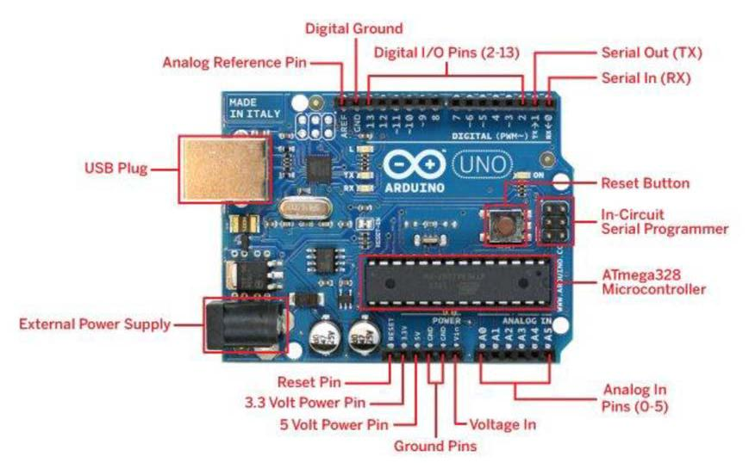

Figure 3.1: Arduino Uno

11

**Technical Specification**

* Microcontroller ATmega328
* Operating Voltage 5V
* Input Voltage (recommended) 7-12V
* Input Voltage (limits) 6-20V
* Digital I/O Pins 14 (of which 6 provide PWM output)
* Analog Input Pins 6
* DC Current per I/O Pin 40 mA
* DC Current for 3.3V Pin 50 mA
* Flash Memory 32 KB of which 0.5 KB used by bootloader
* SRAM 2 KB
* EEPROM 1 KB
* Clock Speed 16 MHz

The Arduino Uno can be powered via the USB connection or with an external power supply. The power source is selected automatically.

External (non-USB) power can come either from an AC-to-DC adapter (wall-wart) or battery. The adapter can be connected by plugging a 2.1mm centre-positive plug into the board's power jack. Leads from a battery can be inserted in the Gnd and Vin pin headers of the POWER connector. The board can operate on an external supply of 6 to 20 volts. If supplied with less than 7V, however, the 5V pin may supply less than five volts and the board may be unstable. If using more than 12V, the voltage regulator may overheat and damage the board. The recommended range is 7 to 12 volts.

12

**The power pins are as follows**

* **VIN.** The input voltage to the Arduino board when it's using an external power source (asopposed to 5 volts from the USB connection or other regulated power source). You can supply voltage through this pin, or, if supplying voltage via the power jack, access it through this pin.
* **5V.** The regulated power supply used to power the microcontroller and other componentson the board. This can come either from VIN via an on-board regulator, or be supplied by USB or another regulated 5V supply.
* **3V3.** A 3.3-volt supply generated by the on-board regulator. Maximum current draw is 50mA.
* **GND.** Ground pins.

**Memory**

The Atmega328 has 32 KB of flash memory for storing code (of which 0,5 KB is used for the boot loader; It has also 2 KB of SRAM and 1 KB of EEPROM (which can be read and written with the EEPROM Library.

**Input & Output**

Each of the 14 digital pins on the Uno can be used as an input or output, using pinMode(), digitalWrite(), and digitalRead() functions. They operate at 5 volts. Each pin can provide or receive a maximum of 40 mA and has an internal pull-up resistor (disconnected by default) of 20-50 kOhms. In addition, some pins have specialized functions:

13

* **Serial: 0 (RX) and 1 (TX).** Used to receive (RX) and transmit (TX) TTL serial data.These pins are connected to the corresponding pins of the ATmega8U2 USB-to-TTL Serial chip .
* **External Interrupts: 2 and 3.** These pins can be configured to trigger an interrupt on alow value, a rising or falling edge, or a change in value. See the attachInterrupt() function for details.
* **PWM: 3, 5, 6, 9, 10, and 11.** Provide 8-bit PWM output with the analogWrite() function.
* **SPI: 10 (SS), 11 (MOSI), 12 (MISO), 13 (SCK).** These pins support SPIcommunication, which, although provided by the underlying hardware, is not currently included in the Arduino language.
* **LED: 13.** There is a built-in LED connected to digital pin 13. When the pin is HIGHvalue, the LED is on, when the pin is LOW, it's off. The Uno has 6 analog inputs, each of which provide 10 bits of resolution (i.e. 1024 different values). By default they measure from ground to 5 volts, though is it possible to change the upper end of their range using the AREF pin and the analogReference() function. Additionally, some pins have specialized functionality:
* **I2C: 4 (SDA) and 5 (SCL).** Support I2C (TWI) communication using the Wire library.There are a couple of other pins on the board:
* **AREF.** Reference voltage for the analog inputs. Used with analogReference().
* **Reset.** Bring this line LOW to reset the microcontroller. Typically used to add a resetbutton to shields which block the one on the board.

14

**Arduino LEDs**

Likewise, the Arduino has **four** LEDs: **L**, **RX**, **TX**, and **ON. On** the UNO, three are in the middle and one is to the right.

* **ON** LED - this LED will shine green whenever the Arduino is powered. Always checkthis LED if Arduino is not acting right, if its flickering or off then check the power supply.
* **RX** and **TX** LEDs - these are like the 'send' and 'receive' LEDs on our cable modem.They blink whenever information is sent from or to the Arduino through the USB connection. The **TX** LED lights up yellow whenever data is sent **from the Arduino to** **the computer** USB port. The **RX** LED lights up yellow whenever data is sent **to the Arduino from the computer** USB port.
* **L** LED - this is the one LED that we can control. The ON, RX and TX LEDs all light upautomatically no matter what. The **L** LED, however, is connected to the Arduino main chip and turn it on or off before start writing code.

**Communication**

The Arduino Uno has a number of facilities for communicating with a computer, another Arduino, or other microcontrollers. The ATmega328 provides UART TTL (5V) serial communication, which is available on digital pins 0 (RX) and 1 (TX). An ATmega8U2 on the board channels this serial communication over USB and appears as a virtual com port to software on the computer. The '8U2 firmware uses the standard USB COM drivers, and no external driver is needed. However, on Windows, an *.inf file is required. The Arduino software

15

includes a serial monitor which allows simple textual data to be sent to and from the Arduino board. The RX and TX LEDs on the board will flash when data is being transmitted via the USB-to serial chip and USB connection to the computer (but not for serial communication on pins 0 and 1). A Software Serial library allows for serial communication on any of the Uno's digital pins. The ATmega328 also support I2C (TWI) and SPI communication. The Arduino software includes a Wire library to simplify use of the I2C bus; see the documentation for details. To use the SPI communication, please see the ATmega328 datasheet.

The Arduino IDE (integrated development environment) supports the languages C and C++ using special rules to organize code. The Arduino IDE supplies a software library called Wiring from the Wiring project, which provides many common input and output procedures. A typical Arduino C/C++ sketch consist of two functions that are compiled.

**3.2Arduino Mega**

The Arduino Mega 2560 is a microcontroller board based on the ATmega2560. It has

54 digital input/output pins (of which 14 can be used as PWM outputs), 16 analog

inputs, 4 UARTs (hardware serial ports), a 16 MHz crystal oscillator, a USB connection, a

power jack, an ICSP header, and a reset button. It contains everything needed to support

the microcontroller; simply connect it to a computer with a USB cable or power it with a

AC-to-DC adapter or battery to get started. The Mega is compatible with most shields

designed for the Arduino Duemilanove or Diecimila.

The Arduino Mega2560 can be powered via the USB connection or with an external power

supply. The power source is selected automatically. External (non-USB) power can come

16

either from an AC-to-DC adapter (wall-wart) or battery. The adapter can be connected by

plugging a 2.1mm center-positive plug into the board's power jack. Leads from a battery

can be inserted in the Gnd and Vin pin headers of the POWER connector.

The board can operate on an external supply of 6 to 20 volts. If supplied with less than 7V,

however, the 5V pin may supply less than five volts and the board may be unstable. If using

more than 12V, the voltage regulator may overheat and damage the board. The

recommended range is 7 to 12 volts.

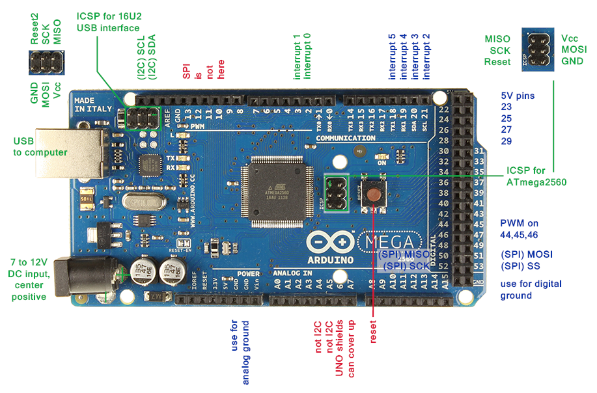

Figure 3.2: Arduino Mega

The Mega2560 differs from all preceding boards in that it does not use the FTDI USB-to-

serial driver chip. Instead, it features the Atmega8U2 programmed as a USB-to-serial

converter.

17

**Technical Specification**

|  |  |  |
| --- | --- | --- |
| * Microcontroller | ATmega2560 | |
| * Operating Voltage | 5 V | |
| * Input Voltage (recommended) | 7-12 V | |
| * Input Voltage (limits) | 6-20 V | |
| * Digital I/O Pins | 54 (of which 14 provide PWM output ) | |
| * Analog Input Pins | 16 | |
| * DC Current per I/O Pin | 40 mA | |
| * DC Current for 3.3V Pin | 50 mA | |
| * Flash Memory | 256 KB of which 8 KB used by bootloader | |
|  | |
| * Clock Speed | 16 MHZ | |
| * SRAM | 8 KB | |
| * EEPROM | 4 KB | |

**The power pins are as follows:**

* **VIN.** The input voltage to the Arduino board when it's using an external power

source (as opposed to 5 volts from the USB connection or other regulated power

source). You can supply voltage through this pin, or, if supplying voltage via the

power jack, access it through this pin.

* **5V.** The regulated power supply used to power the microcontroller and other components on the board. This can come either from VIN via an on-board regulator,

or be supplied by USB or another regulated 5V supply.

18

* **3V3.** A 3.3 volt supply generated by the on-board regulator. Maximum current draw

is 50 mA.

* **GND.** Ground pins.

**some pins have specialized functions:**

* **Serial: 0 (RX) and 1 (TX); Serial 1: 19 (RX) and 18 (TX); Serial 2: 17 (RX) and 16**

**(TX); Serial 3: 15 (RX) and 14 (TX).** Used to receive (RX) and transmit (TX) TTL

serial data. Pins 0 and 1 are also connected to the corresponding pins of the

ATmega8U2 USB-to-TTL Serial chip.

* **External Interrupts: 2 (interrupt 0), 3 (interrupt 1), 18 (interrupt 5), 19 (interrupt**

**4), 20 (interrupt 3), and 21 (interrupt 2).** These pins can be configured to trigger an

interrupt on a low value, a rising or falling edge, or a change in value. See the

attachInterruot()function for details.

* **PWM: 0 to 13.** Provide 8-bit PWM output with the analogWrite()function.
* **SPI: 50 (MISO), 51 (MOSI), 52 (SCK), 53 (SS).** These pins support SPI

communication, which, although provided by the underlying hardware, is not

currently included in the Arduino language. The SPI pins are also broken out on the

ICSP header, which is physically compatible with the Duemilanove and Diecimila.

* **LED: 13.** There is a built-in LED connected to digital pin 13. When the pin is HIGH

value, the LED is on, when the pin is LOW, it's off.

* **I2C: 20 (SDA) and 21 (SCL).** Support I2C communication using the [Wire library](http://wiring.org.co/reference/libraries/Wire/index.html)

(documentation on the Wiring website). Note that these pins are not in the same

location as the I2C pins on the Duemilanove.

19

Communication

The Arduino Mega2560 has a number of facilities for communicating with a computer,

another Arduino, or other microcontrollers. The ATmega2560 provides four hardware

UARTs for TTL (5V) serial communication. An ATmega8U2 on the board channels one of

These over USB and provides a virtual com port to software on the computer (Windows

Machines will need a inf file, but OSX and Linux machines will recognize the board as a

COM port automatically. The Arduino software includes a serial monitor which allows simple

textual data to be sent to and from the board. The RX and TX LEDs on the board will flash

when data is being transmitted via the ATmega8U2 chip and USB connection to the

computer (but not for serial communication on pins 0 and 1). A software library allows for

serial communication on any of the Mega's digital pins.

The ATmega2560 also supports I2C (TWI) and SPI communication. The Arduino software

includes a Wire library to simplify use of the I2C bus.

**3.3 Arduino Ethernet Shield**

The **Ethernet Shield** allows an Arduino board to connect to the internet. It is based on the Wiznet

W5100 ethernet chip (datasheet). The Wiznet W5100 provides a network (IP) stack capable of

both TCP and UDP. It supports up to four simultaneous socket connections. Use the Ethernet

library to write sketches which connect to the internet using the shield. The ethernet shield

connects to an Arduino board using long wire-wrap headers which extend through the shield. This

keeps the pin layout intact and allows another shield to be stacked on top.

20

The most recent revision of the board exposes the 1.0 pinout on rev 3 of the Freaduino UNO

board. The Ethernet Shield has a standard RJ-45 connection, with an integrated line transformer

and Power over Ethernet enabled. There is an onboard micro-SD card slot, which can be used to

store files for serving over the network. It is compatible with the Arduino Uno and Mega (using

the Ethernet library). The onboard microSD card reader is accessible through the SD Library.

When working with this library, SS is on Pin 4.The shield also includes a reset controller, to

ensure that the W5100 Ethernet module is properly reset on power-up.

Arduino communicates with both the W5100 and SD card using the SPI bus (through the ICSP

header). This is on digital pins 11, 12, and 13 on the Duemilanove and pins 50, 51, and 52 on the

Mega. On both boards, pin 10 is used to select the W5100 and pin 4 for the SD card. These pins

cannot be used for general i/o. On the Mega, the hardware SS pin, 53, is not used to select either

the W5100 or the SD card, but it must be kept as an output or the SPI interface won't work.

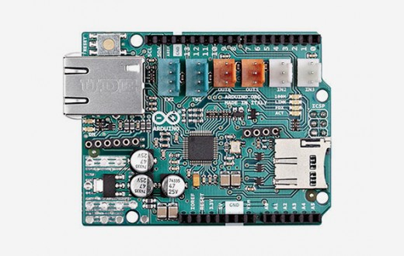

Figure 3.3: Ethernet Shield

21

**Feature of Ethernet Shield**

* Standard Arduino and Arduino Mega compatible
* Ethernet：WIZ5100
* Standard RJ45 Ethernet interface
* Arduino Ethernet Library compatible
* Support Micro SD Card（no more than 2GB）

* Arduino/ Freaduino/Mega fully compatible
* Easy to access reset button
* Up to 4 TCP/UDP network connections
* SD Card IO CS:D4 ;MOSI:D11;SCK:D13;MISO:D12
* Operating voltage：DC5-12V
* Dimension：78mmx53.5m

**Technical Specification**

|  |  |  |  |  |  |  |
| --- | --- | --- | --- | --- | --- | --- |
| Microcontroller | |  | |  | ATmega328 | |
| Operating Voltage | |  | |  | 5V | |
| Input Voltage Plug(limits) | |  | |  | 6-18V | |
| Input Voltage PoE (limits) | |  | |  | 36-57V | |
| Digital I/O Pins  Arduino Pins reserved | |  | |  | 14 (of which 4 provide PWM output)  10 to 13 used for SPI | |
|  | |  | |  |  | |  | | *4 used for SD card* |
|  | | 22 | |  |  | |
| Analog Input Pins | |  | |  | 6 | |  | | 6 |
|  | |  | |  |  | |  | | 40 mA |
| DC Current for 3.3V Pin | |  | |  | | | 50 mA | |
| SRAM | |  | |  | | | 2 KB (ATmega328) | |
| EEPROM | |  | |  | | | 1 KB (ATmega328) | |
| Clock Speed  W5100 TCP/IP Embedded Ethernet | |  | |  | | | 16 MHz | |

**The power pins are as follows**:

* **VIN.** The input voltage to the Arduino board when it's using an external power source (as

opposed to 5 volts from the USB connection or other regulated power source). You can

supply voltage through this pin, or, if supplying voltage via the power jack, access it

through this pin.

* **5V.** The regulated power supply used to power the microcontroller and other
* components on the board. This can come either from VIN via an on-board regulator, or

be supplied by USB or another regulated 5V supply.

* **3V3.** A 3.3 volt supply generated by the on-board regulator. Maximum current draw is 50

mA.

* **GND.** Ground pins.

# **Input and output**

Each of the 14 digital pins on the Ethernet board can be used as an input or output, using

pinMode(),digitalWrite() and digitalRead() functions. They operate at 5 volts. Each pin can

provide or receive a maximum of 40 mA and has an internal pull-up resistor (disconnected by

default) of 20-50 kOhms. In addition, some pins have specialized functions:

23

* **Serial: 0 (RX) and 1 (TX).** Used to receive (RX) and transmit (TX) TTL serial data.

* **External Interrupts: 2 and 3.** These pins can be configured to trigger an interrupt on a low

value, a rising or falling edge, or a change in value.

* **PWM: 3, 5, 6, 9, and 10.** Provide 8-bit PWM output with the analohWrite()function.
* **SPI: 10 (SS), 11 (MOSI), 12 (MISO), 13 (SCK).** These pins support SPI communication using

the SPI library()[.](http://arduino.cc/en/Reference/SPI)

* **LED: 9.** There is a built-in LED connected to digital pin 9. When the pin is HIGH value, the

LED is on, when the pin is LOW, it's off. On most other arduino boards, this LED is found

on pin 13. It is on pin 9 on the Ethernet board because pin 13 is used as part of the SPI

connection.

The Ethernet board has 6 analog inputs, labeled A0 through A5, each of which provide 10 bits of

resolution (i.e. 1024 different values). By default they measure from ground to 5 volts, though is

it possible to change the upper end of their range using the AREF pin and the analogReference().

function. Additionally, some pins have specialized functionality:

* **TWI: A4 (SDA) and A5 (SCL).** Support TWI communication using the wire library.

**There are a couple of other pins on the board:**

* **AREF.** Reference voltage for the analog inputs. Used with an alogRefference[(](http://arduino.cc/en/Reference/AnalogReference)).

* **Reset.** Bring this line LOW to reset the microcontroller. Typically used to add a reset

button to shields which block the one on the board.

24

**Connecting the shield**

To use the shield, mount it on top of an Arduino board (e.g. the Uno). To upload sketches to the

board, connect it to your computer with a USB cable as you normally would. Once the sketch has

been uploaded, you can disconnect the board from your computer and power it with an external

power supply.

Connect the shield to your computer or a network hub or router using a standard ethernet cable

(CAT5 or CAT6 with RJ45 connectors). Connecting to a computer may require the use of a cross-

over cable (although many computers, including all recent Macs can do the cross-over internally).

**Network setting**

The shield must be assigned a MAC address and a fixed IP address using the Ethernet.begin()

function. A MAC address is a globally unique identifier for a particular device. Current Ethernet

shields come with a sticker indicating the MAC address you should use with them. For older

shields without a dedicated MAC address, inventing a random one should work, but don't use the

same one for multiple boards. Valid IP addresses depend on the configuration of your network. It

is possible to use DHCP to dynamically assign an IP to the shield. Optionally, you can also

specify a network gateway and subnet.

It is possible to program the Arduino Ethernet board in two ways: through the 6 pin serial

programming header, or with an external ISP programmer.

**Programming**

The 6-pin serial programming header is compatible with FTDI USB cables and the Sparkfun and

Adafruit FTDI-style basic USB-to-serial breakout boards including the Arduino USBSerial

25

connector. It features support for automatic reset, allowing sketches to be uploaded without

pressing the reset button on the board. When plugged into a FTDI-style USB adapter, the Arduino

Ethernet is powered off the adapter.

You can also program the Ethernet board with an external programmer like an AVRISP mkII or

USBTinyISP. All the Ethernet example sketches work as they do with the Ethernet shield. Make

sure to change the network settings for your network.

**3.4 RFID (RC522) sensor and card**

A radio frequency identification reader (RFID reader) is a device used to gather information from an RFID tag, which is used to track individual objects. Radio waves are used to transfer data from the tag to a reader. RFID is a technology similar in theory to bar codes. However, the RFID tag does not have to be scanned directly, nor does it require line-of-sight to a reader. The RFID tag it must be within the range of an RFID reader, which ranges from 3 to 300 feet, in order to be read. RFID technology allows several items to be quickly scanned and enables fast identification of a particular product, even when it is surrounded by several other items. Even though this device was a covert listening device, not an identification tag, it is considered to be a predecessor of RFID, because it was likewise passive, being energized and activated by waves from an outside source.

MF RC522 is used in highly integrated 13.56MHz contactless communication card chip to read and write, of NXP for “three” and the application launched a low voltage, low cost, small size, non-contact card chips to read and write, intelligent instruments and portable handheld devices developed better. The MF RC522 use of advanced modulation and demodulation concept completely integrated in the 13.56MHz all kinds of passive contactless communication methods and protocols. 14443A compatible transponder signal. The digital part handles the ISO14443A

26

frames and error detection. In addition, support Quick CRYPTO1 encryption algorithm, the term verification MIFARE series. MFRC522 support MIFARE series of high-speed non-contact communication, two-way data transfer rates up to 424kbit / s.As 13.56MHz highly integrated card

reader series chip new family, the MF RC522 MF RC500 MF RC530 there are many similarities, but also have many of the characteristics and differences. Communication between it and the host SPI mode, helps to reduce the connection, reduce PCB board volume and reduce costs.

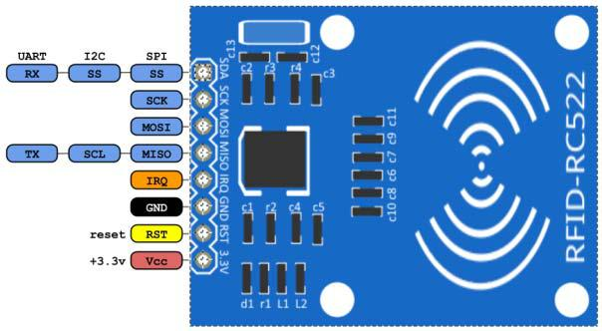

Figure 3.4: RFID-RC522

**Features:**

* Highly integrated analog circuitry to demodulate and decode responses
* Buffered output drivers to connect an antenna with minimum number of external components
* Supports ISO/IEC 14443A / MIFARE®
* Typical operating distance in Reader/Writer mode for communication to a
* ISO/IEC 14443A / MIFARE® up to 50 mm depending on the antenna size and tuning
* Supports MIFARE® Classic encryption in Reader/Writer mode
* Supports ISO/IEC 14443A higher transfer speed communication up to 848 kbit/s
* Support of the MFIN / MFOUT

27

* Supported host interfaces
* SPI interface up to 10 Mbit/s
* I2C interface up to 400 kbit/s in Fast mode, up to 3400 kbit/s in High-speed mode
* serial UART in different transfer speeds up to 1228.8 kbit/s, framing according to the RS232 interface with voltage levels according pad voltage supply
* Comfortable 64 byte send and receive FIFO-buffer
* Flexible interrupt modes
* Hard reset with low power function
* Power-down mode per software
* Programmable timer
* Internal oscillator to connect 27.12 MHz quartz
* 2.5 - 3.3 V power supply
* CRC Co-processor
* Free programmable I/O pins
* Internal self-test

28

**Specifications:**

* Module Name: Rfid-RC522
* Working current：13—26mA/ DC 3.3V
* Standby current：10-13mA/DC 3.3V
* sleeping current：<80uA
* peak current：<30mA
* Working frequency：13.56MHz
* Card reading distance ：0～60mm（mifare1 card）
* Protocol：SPI
* data communication speed：Maximum 10Mbit/s
* Card types supported：mifare1 S50、mifare1 S70、mifare UltraLight、mifarePro、 mifareDesfire
* Dimension：40mm×60mm
* Environment
* Working temperature：-20—80 degree
* Storage temperature：-40—85 degree
* Humidity：relevant humidity 5%—95%
* Max SPI speed: 10Mbit/s

29

**Block Diagram**

The Analog interface handles the modulation and demodulation of the analog signals. The contactless UART handles the protocol requirements for the communication schemes in co-operation with the host. The comfortable FIFO buffer allows a fast and convenient data transfer from the host to the contactless UART and vice versa. Various host interfaces are implemented to fulfil different customer requirements.

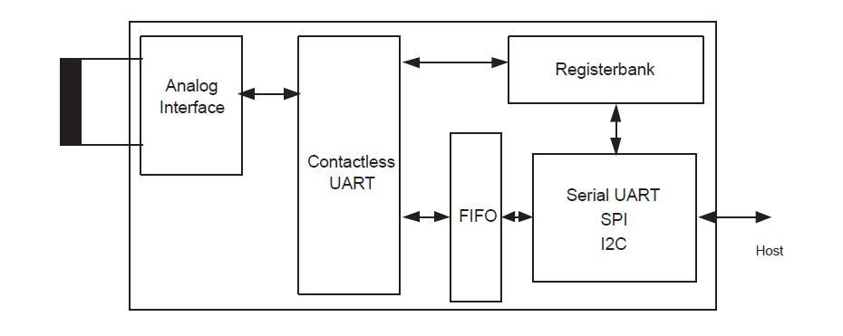

Fig 3.5: Simplified MFRC522 Block diagram.

**RFID Card**

RFID tagging is an ID system that uses small radio frequency identification devices for identification and tracking purposes. An RFID tagging system includes the tag itself, a read/write device, and a host system application for data collection, processing, and transmission. An RFID tag (sometimes called an RFID transponder ) consists of a chip , some memory and an antenna .

30

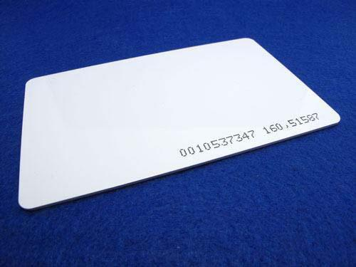

Figure 3.6: RFID Tag 1

Every system has to start with selecting an **RFID tag** that will perform well given your reading requirements, size constraints, and application type. A tag consists of two parts: the chipset and antenna. Normally, the larger the antenna the better range you will get. There are a variety of chipsets and antenna designs which are designed to perform in all types of applications.

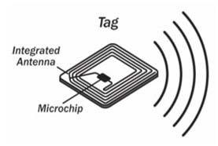

Fig 3.7: RFID tag 2

31

**3.5 Camera OV7670**

The OV7670/OV7171 CAMERACHIPTM is a low voltage CMOS image sensor that provides the

full functionality of a single-chip VGA camera and image processor in a small footprint package.

The OV7670/OV7171 provides full-frame, sub-sampled or windowed 8-bit images in a wide

range of formats, controlled through the Serial Camera Control Bus (SCCB) interface. This

product has an image array capable of operating at up to 30 frames per second (fps) in VGA with

complete user control over image quality, formatting and output data transfer. All required image

processing functions, including exposure control, gamma, white balance, color saturation, hue

control and more, are also programmable through the SCCB interface. In addition, OmniVision

CAMERACHIPs use proprietary sensor technology to improve image quality by reducing or

eliminating common lighting/electrical sources of image contamination, such as fixed pattern

noise (FPN), smearing, blooming, etc., to produce a clean, fully stable color image.

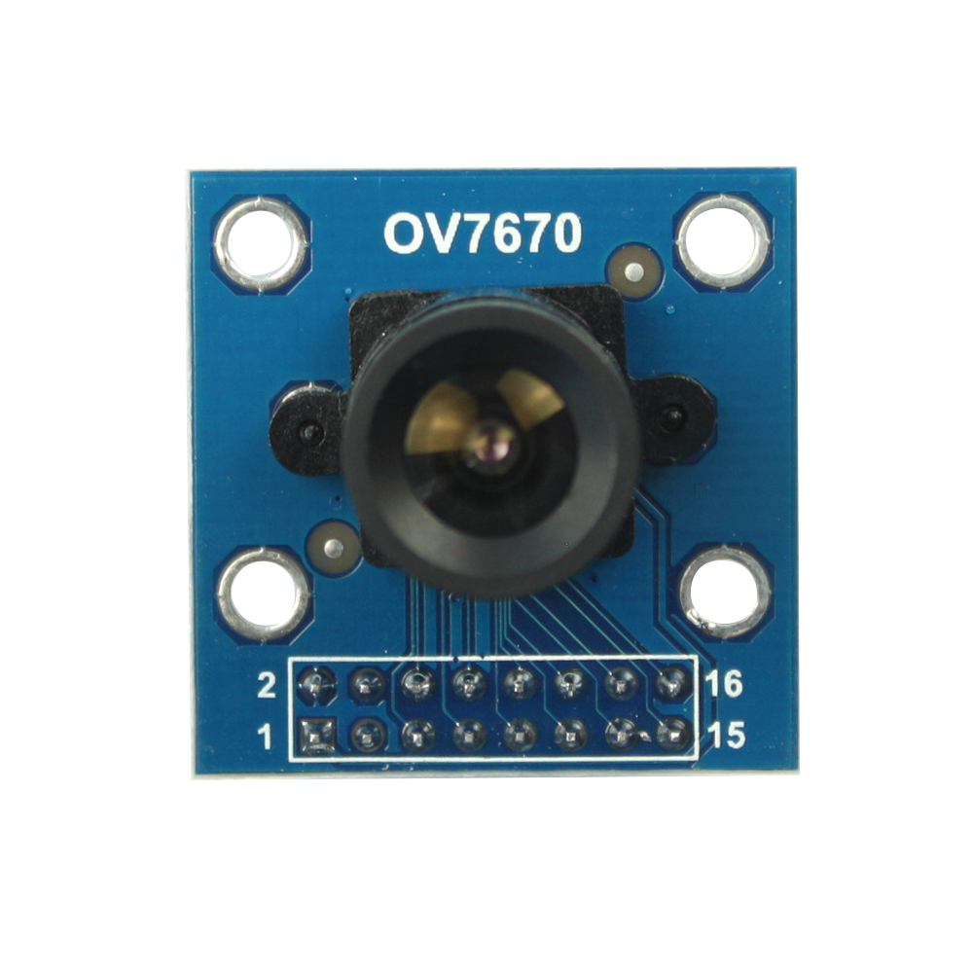

Figure 3.8: Camera OV7670

32

**Featue of camera OV7670**

* Optical size 1/6 inch
* Resolution 640×480 VGA
* Onboard regulator, only single 3.3V supply needed
* Standard 0.1inch (2.54mm) pin pitch header connector
* Mounted with high quality F1.8 / 6mm lens
* Output support for Raw RGB, RGB (GRB 4:2:2, RGB565/555/444), YUV (4:2:2) and

YCbCr (4:2:2) formats

* High sensitivity for low-light operation
* Low operating voltage for embedded portable apps
* Standard SCCB interface compatible with I2C interface
* Supports image sizes: VGA, CIF, and any size scaling down from CIF to 40×30
* VarioPixel® method for sub-sampling
* Automatic image control functions including: Automatic
* Exposure Control (AEC), Automatic Gain Control (AGC), Automatic White Balance

(AWB)

* Band Filter (ABF), and Automatic Black-Level Calibration (ABLC)
* Image quality controls including color saturation, hue, gamma, sharpness (edge

enhancement),and anti-blooming

* ISP includes noise reduction and defect correction
* Supports LED and flash strobe mode
* Supports scaling
* Lens shading correction
* Flicker (50/60 Hz) auto detection
* Saturation level auto adjust (UV adjust)

33

* Edge enhancement level auto adjust
* De-noise level auto adjust

**Pin Description**

|  |  |  |  |
| --- | --- | --- | --- |
| **Pin No.** | **PIN NAME** | **TYPE** | **DESCRIPTION** |
| 1 | VCC | POWER | 3.3v Power supply |
| 2 | GND | Ground | Power ground |
| 3 | SCL | Input | Two-Wire Serial Interface Clock |
| 4 | SDATA | Bi-directional | Two-Wire Serial Interface Data I/O |
| 5 | VSYNC | Output | Active High: Frame Valid; indicates active frame |
| 6 | HREF | Output | Active High: Line/Data Valid; indicates active pixels |
| 7 | PCLK | Output | Pixel Clock output from sensor |
| 8 | XCLK | Input | Master Clock into Sensor |
| 9 | DOUT9 | Output | Pixel Data Output 9 (MSB) |
| 10 | DOUT8 | Output | Pixel Data Output 8 |
| 11 | DOUT7 | Output | Pixel Data Output 7 |
| 12 | DOUT6 | Output | Pixel Data Output 6 |
| 13 | DOUT5 | Output | Pixel Data Output 5 |
| 14 | DOUT4 | Output | Pixel Data Output 4 |
| 15 | DOUT3 | Output | Pixel Data Output 3 |
| 16 | DOUT2 | Output | Pixel Data Output 2 (LSB) |

34

**3.6 LCD Display 16x2**

A liquid-crystal display (LCD) is a flat-panel display or other electronically modulated optical device that uses the light-modulating properties of liquid crystals. Liquid crystals do not emit light directly, instead using a backlight or reflector to produce images in color or monochrome. LCDs are available to display arbitrary images (as in a general-purpose computer display) or fixed images with low information content, which can be displayed or hidden, such as preset words, digits, and 7-segment displays, as in a digital clock. They use the same basic technology, except that arbitrary images are made up of a large number of small pixels, while other displays have larger elements.[8]

This example sketch prints "Hello World!" to the LCD and shows the time in seconds since the

Arduino was reset:

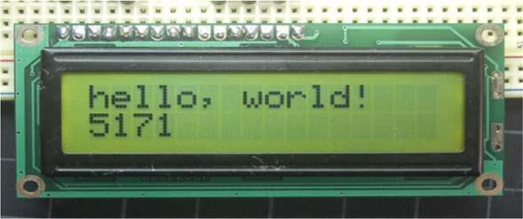

Figure 3.9: 16x2 LCD Display

35

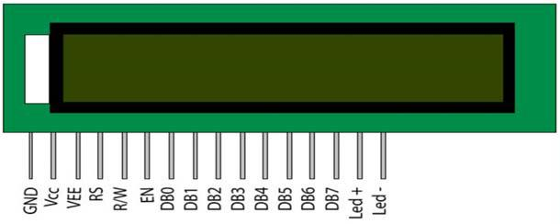

|  |  |  |  |
| --- | --- | --- | --- |
|  |  | Figure 3.10: Pin Diagram |  |
| **Pin No** | **Symbol** | **Level** | **Description** |
| 1 | VSS | 0V | Ground |
| 2 | VDD | 5V | Supply Voltage for logic |
| 3 | VO | (Variable) | Operating voltage for LCD |
| 4 | RS | H/L | H: DATA, |
|  |  |  | L: Instruction code |
| 5 | R/W | H/L | H: Read(MPU?Module) |
|  |  |  | L: Write(MPU?Module) |
| 6 | E | H,H->L | Chip enable signal |
| 7 | DB0 | H/L | Data bus line |
| 8 | DB1 | H/L | Data bus line |
| 9 | DB2 | H/L | Data bus line |
| 10 | DB3 | H/L | Data bus line |
| 11 | DB4 | H/L | Data bus line |
| 12 | DB5 | H/L | Data bus line |
| 13 | DB6 | H/L | Data bus line |
| 14 | DB7 | H/L | Data bus line |
| 15 | A | 5V | LED + |
| 16 | K | 0V | LED- |

36

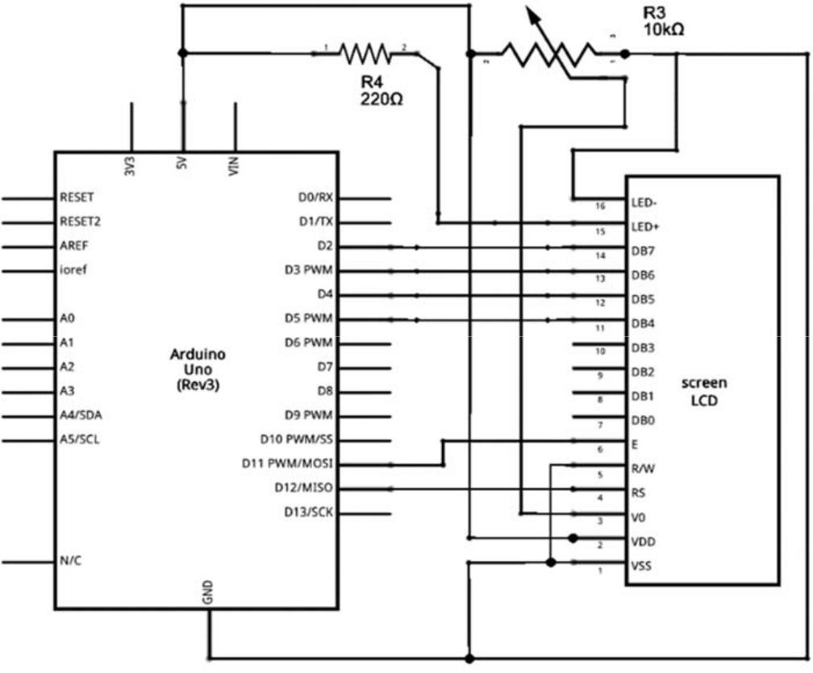

Figure 3.11: Schematic diagram of Arduino Uno & LCD Display

**3.7 IIC/I2C Serial Interface Module**

This is a RoHS compliant I2C Serial LCD Daughter board that can be connected to a standard HD44780compatible 16x2 or 20x4 Character Display Module that supports 4-bit mode. All Character Modules sold on our site support 4-bit mode, and nearly all commercially available 16x2 and 20x4 line character modules support it too. [9]

This board has a PCF8574 I2C chip that converts I2C serial data to parallel data for the LCD display. There are many examples on internet for using this board with Arduino. Do a search for "Arduino LCD PCF8574". The I2C address is 0x3F by default, but this can be changed via 3 solder jumpers provided on the board.

37

This allows up to 3 LCD displays to be controlled via a single I2C bus (giving each one its own address).

* 5V power supply
* Serial I2C control of LCD display using PCF8574
* Backlight can be enabled or disabled via a jumper on the board
* Contrast control via a potentiometer
* Can have 8 modules on a single I2C bus (change address via solder jumpers) address, allowing
* Size：41.6mm x 19.2mm

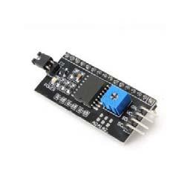

Figure 3.12: IIC/I2C Serial Interface Module

These serial interface modules simplify connecting an Arduino to a 16x2 Liquid Crystal display using only 4 wires.

**3.8 Sonar Sensor**

This is the HC-SR04 ultrasonic ranging sensor. This economical sensor provides 2cm to 400cm of non-contact measurement functionality with a ranging accuracy that can reach up to 3mm. Each HC-SR04 module includes an ultrasonic transmitter, a receiver and a control circuit. [11,12]

38

There are only four pins that you need to worry about on the HC-SR04: VCC (Power), Trig (Trigger), Echo (Receive), and GND (Ground). Ultrasonic ranging module HC - SR04 provides 2cm - 400cm non-contact measurement function, the ranging accuracy can reach to 3mm. The modules include ultrasonic transmitters, receiver and control circuit. The basic principle of work:

* Using IO trigger for at least 10us high level signal,
* The Module automatically sends eight 40 kHz and detect whether there is a pulse signal back.
* IF the signal back, through high level, time of high output IO duration is the time from sending ultrasonic to returning.

Test distance = (high level time×velocity of sound (340M/S) / 2

**Pin configuration of sonar sensor:**

* 5V Supply
* Trigger Pulse Input
* Echo Pulse Output

* 0V Ground

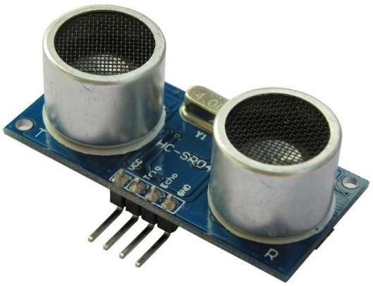

Figure 3.13: Sonar sensor

39

**3.9 Buzzer**

A buzzer or beeper is an audio signaling device which maybe mechanical, electromechanical, or piezoelectric. Typical uses of buzzers and beepers include alarm devices, timers, and confirmation of user input such as a mouse click or keystroke.[13]

Buzzer is an integrated structure of electronic transducers, DC power supply, widely used in computers, printers, copiers, alarms, electronic toys, automotive electronic equipment, telephones, timers and other electronic products for sound devices. Active buzzer 5V Rated power can be directly connected to a continuous sound, this section dedicated sensor expansion module and the board in combination, can complete a simple circuit design, to "plug and play."

**Pin configuration of buzzer:**

1. VCC
2. Input
3. Ground

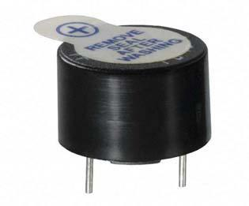

Figure 3.14: Buzzer

40

**LCD 16x2 Output:**

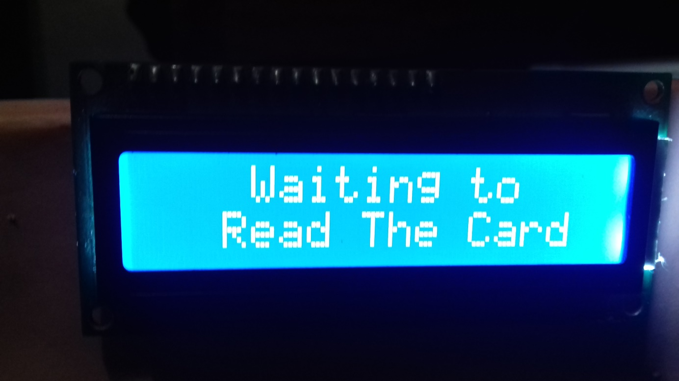

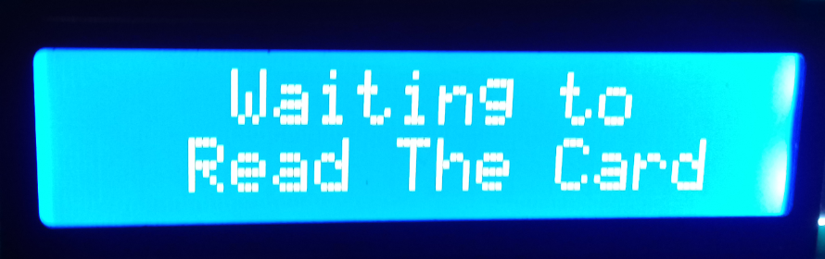

Figure 3.15: Output 1

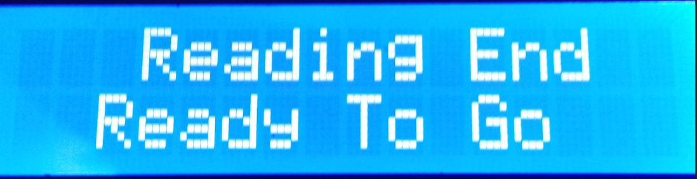

Figure 3.16: Output 2

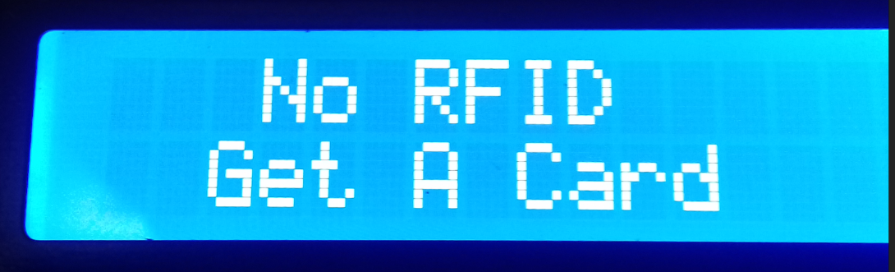

Figure 3.17: Output 3

41

**Hardware Connections:**

To create this hardware connection we use Fritzing software and by the by we also create its schematic diagram using the same software in the next figure.We add all the sensor’s that we use in our project .We use one arduino,one RFID RC 522,one servo motor, two ultrasonic for different purpose of use,one buzzer , one lcd 16x2 display,one breadboard and LED’s . We all connect them by wire and designed our hardware connection.

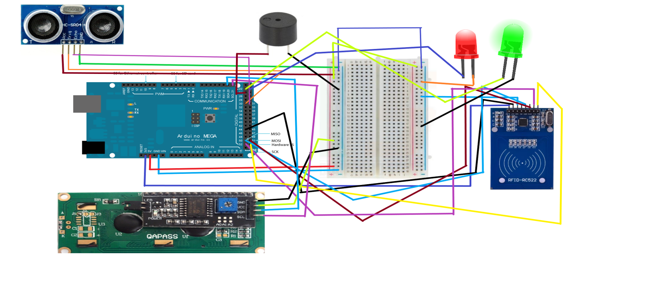

Figure 3.18: Hardware Connections.

42

**Prototype of the Toll System:**

This image is captured by the side view of the prototype. Black and white colors is the road sign. We create our prototype by one-way road and manual toll payed booth is build left side of the design. All the sensors are put in this prototype by our system design. There will have RFID sensor Frist, that will read the card. If he does have a valid card then he will be free to go. And if do not have a RFID it will be read by the ultrasonic sensor. A camera will capture the photo of the car. Car RFID No. or the Picture All of these data will be stored in database. So all the things we can easily checked from Database.

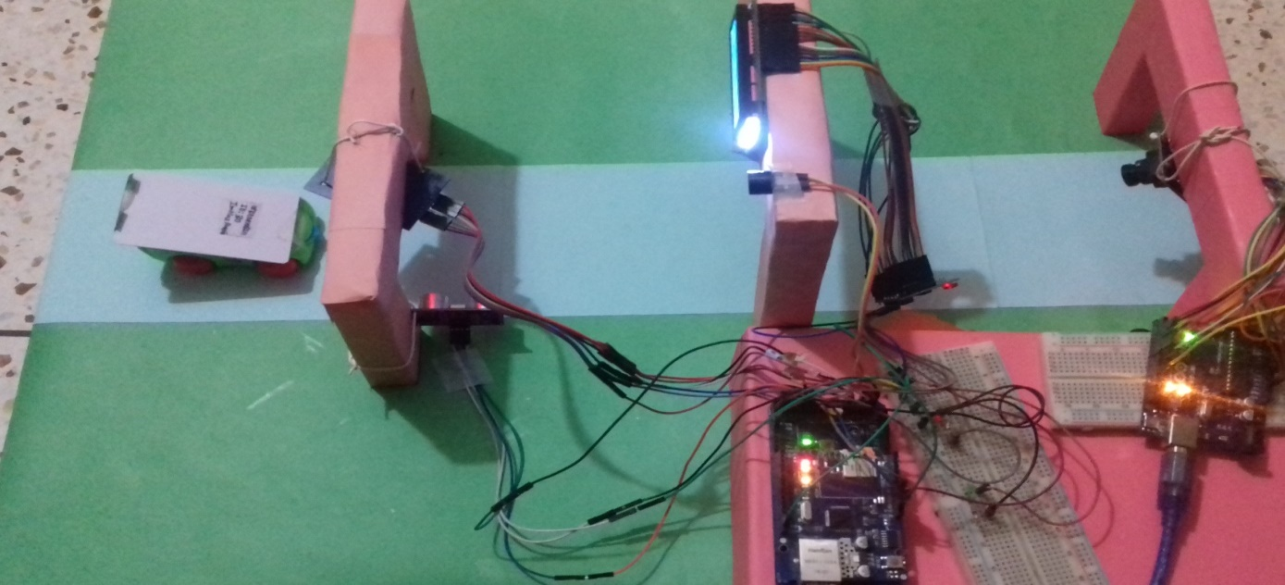

Figure 3.19: Prototype of the toll system.

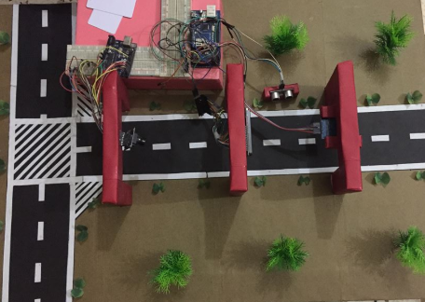

Figure 3.20: Prototype of the toll system (Road View)

43

**Chapter 4**

**Description of the Software System**

**4.1 Introduction**

In our project, we have used programming reference for the command structure and the basic syntax of the Arduino microcontroller and continues to describe the syntax of the most common elements of the languages and illustrates their usage with examples and code fragments which includes many functions of the core library of sample schematics and started programs. Written with the basic structure of Arduino’s C & C++ derived programming language.

We have used Arduino Uno R3 which can be programmed using the Arduino’s Desktop IDE software for offline use which can be downloaded from their website which supports Operating Systems of Windows, Mac OS X, Linux and Portable IDE (for Windows and Linux only), although Online IDE is available for use with internet connection. We have to select "Arduino Uno w/ATmega328" from the **Tools > Board** menu (microcontroller on our board). This ATmega328 on our used Arduino Uno R3 microcontroller comes with pre-burned with a boot-loader that allows us to upload new code to it without the use of an external hardware programmer.

44

**4.2 Structure**

The Arduino Language’s basic structure is very simple and contains at least two parts or function. This functions enclose blocks of statements. This two function is setup() and loop() function.

Void setup()

{

statements ;

}

Void loop()

{

statements ;

}

The both setup() and loop() function is required for the program to run.

Where setup() function contains preparation statements of the program and it contains declaration of variables . At the beginning of the program this function is run and for once after each power up or reset of the Arduino board and it is used to set pinMode or initialize the serial communication. This function initializes and sets the initial values.

The loop() function contains execution statements of the program and after run the setup() function, the loop() function is run and it contains the code which will be executed continuously like reading input, triggering output etc. This function allowing our program to change and respond and to actively control the Arduino board. Actually loop() function is the core of all the Arduino program and it does the bulk of the work.

45

**4.3 Variable Declaration**

Variable is used for naming and storing a value for use it later by the program. Before use variables, we need to declare this variables that means defining its type and optionally assign its initial value.

This declaration needs only once at a time in a program but later value can be changed using arithmetic and others assignments. It can be declare in any location throughout the program. [14]

Some Variable types are:

* int
* char
* flot
* doube
* byte
* Unsigned int
* long
* unsigned long Example:

int scan Variable = 4; //initialize the scan Variable as integer value 4

**4.4 Arithmetic Operator**

By using Arithmetic Operators, we can perform addition, subtraction, multiplication and division of operands. We also get remainder and the results are saved into variables using assignment operator.

46

Arithmetic Operators are:

* Assignment Operator ( = )
* Addition Operator ( + )
* Subtraction Operator ( - )
* Multiplication Operator ( * )
* Division Operator ( / )
* Modulo Operator ( %)

Examples:

x = a + 7;

y = b – 5;

z = c * 3;

m = d / 6;

n = e % 5;

**4.5 Compound Operator**

By using Compound Operators, we can perform increment, decrement, compound addition, compound subtraction, compound multiplication, compound division, compound modulo, compound bitwise AND, compound bitwise OR etc. Actually this operator combines arithmetic operation with variable assignment and most commonly used on loop operations. Arithmetic Operators are:

* Increment Operator ( ++ )
* Decrement Operator ( -- )
* Compound Addition ( +=)

47

* Compound Subtraction ( -= )
* Compound Multiplication (*= )
* Compound Division ( /= )
* Compound Modulo ( %= )
* Compound Bitwise **AND** ( &= )
* Compound Bitwise **OR** ( |= )

Examples:

a++;

b--;

c += x;

d -= y;

x *= y;

x /= y;

// increment a by 1

// decrement b by 1

// increment c by +x

// decrement d by -y

// multiple x by y and save to x

//divide x by y and save to x

**4.6 Boolean Operator**

By using Boolean Operator, we can compare two expressions and get Boolean value and it return a Boolean value of 0 or 1. If the value is TRUE, it returns 1 and if the value is FALSE, it returns

1. This operators are frequently used inside the condition of an if statement. Boolean Operators are:

* Logical AND ( && )
* Logical OR ( || )
* Logical Not ( ! )

48

Examples:

if(x>2 && x<9) { … } if(x>2 || y>2) { … } if(!x) { … }

// if only both expression are true, it will return TRUE // if any expression is true, it will return TRUE // if operand is false, it will return TRUE

**4.7 pinMode(pin,mode)**

Digital I/O function pinMode are used in void setup() to configure the specified pin to behave either as an INPUT or as an OUTPUT.

Its syntax is pinMode(pin, mode), here, the two parameters here pin’s value will be the number of pin whose mode we wish to set and mode’s value will be INPUT, OUTPUT or INPUT_PULLUP and this function will not return anything.[15]

**Example:**

int ledPin = 13; void setup() {

// LED connected to digital pin 13

pinMode(ledPin, OUTPUT); // sets the digital pin as output

}

void loop()

{

digitalWrite(ledPin, HIGH); // sets the LED on

delay(1000); // waits for a second

49

digitalWrite(ledPin, LOW); // sets the LED off

delay(1000); // waits for a second

}

**4.8 digitalWrite(pin, Value)**

digitalWrite() function writes a HIGH or LOW value to a specified digital pin and this pin can be

specified as a variable or constant. Its syntax is written as digitalWrite(pin, value), where the

parameter pin is for the pin number and value can be either HIGH or LOW.[16]

Example:

int ledPin = 13; // LED connected to digital pin 13

void setup(

{

pinMode(ledPin, OUTPUT); // sets the digital pin as output

}

void loop()

{

digitalWrite(ledPin, HIGH); // sets the LED on

delay(1000); // waits for a second

digitalWrite(ledPin, LOW); // sets the LED off

delay(1000); // waits for a second

}

In this code, sets pin 13 to HIGH, makes a one-second-long delay, and sets the pin back to LOW.

50

**4.9 Delay(ms)**

The Delay() function actually pauses the program for the millisecond amount of time. Its syntax is written as delay(ms). Its parameter is ms means millisecond is the value of number of milliseconds to pause. there are 1000 millisecond in a second.

Example:

delay(1000);

// pause for 1 second (1000 millisecond)

**4.10 Serial.begin(speed)**

Serial.begin() function is used to open serial port and set the data rate in bits per second (baud) for serial data transmission. The typical baud rate for communicating with the computer is 9600 although other speeds are supported like 300, 600, 1200, 2400, 480014400, 19200, 28800, 38400, 57600, or 115200 etc. When using serial communication, digital pins 0(RX) and 1(TX) cannot be used at the same time.

Its Syntax is Serial.begin(speed). speed parameter is value in bits per second (baud).

Optional config parameter can be used for set data, parity, and stop bits.

Example:

void setup() {

Serial.begin(9600); // open serial port and sets data rate to 9600 bps

}

51

**4.11 Serial.printIn(val)**

Serial.println() function is used to print data to the serial port as human readable ASCII text followed by a carriage return character and a newline character. This command takes the same forms as Serial.print() but it is easier for reading data serial monitor.

Its syntax is written as Serial.println(val), where the parameter val can be the value to print of any data type. Optional parameter format can be used for specify the number base for integer data types and number of decimal places for floating point types. [17] Example:

int analogValue = 0; // variable to hold the analog value

void setup() {

Serial.begin(9600);

// open the serial port at 9600 bps

}

void loop() {

analogValue = analogRead(0);

// read the analog input on pin 0

// print it out in many formats

Serial.println(analogValue); Serial.println(analogValue, DEC); Serial.println(analogValue, HEX); Serial.println(analogValue, OCT);

// print as an ASCII-encoded decimal

// print as an ASCII-encoded decimal

// print as an ASCII-encoded hexadecimal

// print as an ASCII-encoded octal

Serial.println(analogValue, BIN); // print as an ASCII-encoded binary

delay(10); // delay 10 milliseconds before the next reading

}

52

**4.12 Database Overview:**

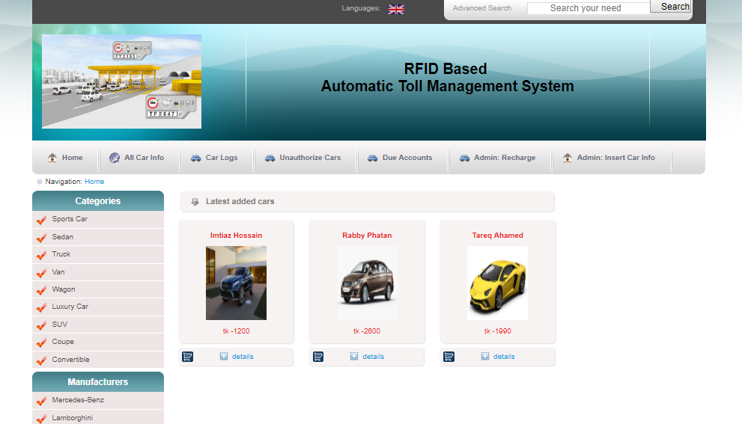

Figure 4.1: home view

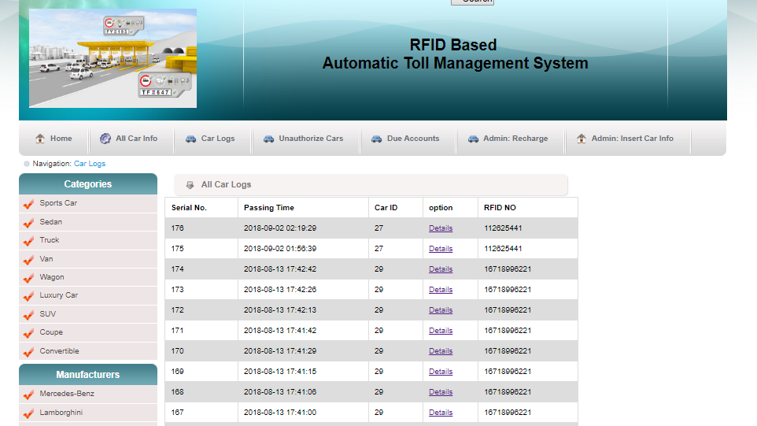

Figure 4.2: All Carlogs

53

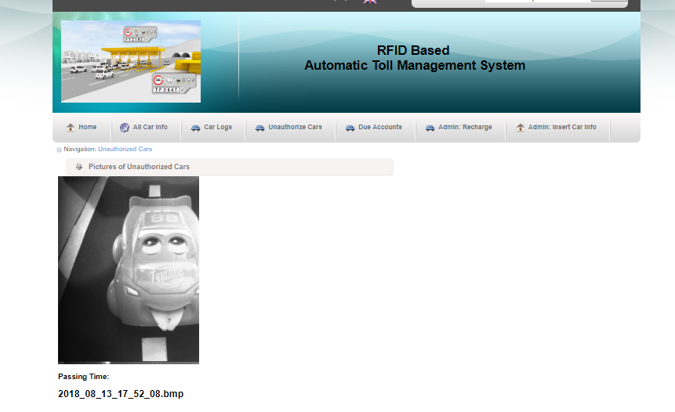

Figure 4.3: Unauthorized Cars

54

**Chapter 5**

**Conclusion**

We have successfully implemented our method on the proposed automated toll collection system. Our toll collection system is very fast and efficient mode for collection toll. This saves a lot of time since vehicles passing through the toll system do not stop to pay toll and the payment automatically takes place from the account of the vehicle. It is observed that there is reduction in the number of accident caused near the toll plazas due to considerable decrement in congestion around toll system. Since the vehicles do not stop at the toll facility. This has reduced the congestion of the toll system nicely.

This toll collection system is mainly based on RFID, a design scheme is given hardware section. The whole system is developed to faster the toll collection system and ensure security in highways and bridges. Usage of RFID technology ensures the system as a secure system as RFID holds a unique identification number and there is no chance of cloning. It is low cost, high security, far communication and efficiency, etc. This toll collection system using RFID is an effective measure to reduce management costs and fees, at the same time, greatly reduce noise and pollutant emission of toll station. In the design of the proposed toll system, real life toll collection, anti-theft or without any RIFD card user car is caught automatically at the toll booth so this system has been designed. This system of collecting tolls is ecofriendly and also results in increased toll lane capacity. Also an anti-theft solution system module which prevents passing of any defaulter vehicle is implemented, thus assuring security on the roadways. On the whole, the system is hassle free and user friendly.

55

**5.1 Future Work**

In our Future improvement we use high speed image capture camera so that any car can’t bypass our system or doing any unethical activity on road. We will make sure that it will capture image real quick. We will make a better RFID reader that can read RFID card from a better distance. We also try to make our system more accurate. Also we will be probably implementing the real time database which is connect with government created roads and highway database server and it will send instant message to the user.

56

**References**

1. https://www.arduino.cc/en/Guide/Introduction
2. https://www.arduino.cc
3. https://en.wikipedia.org/wiki/Arduino#History
4. https://playground.arduino.cc/Learning/MFRC522
5. https://www.techopedia.com/definition/26992/radio-frequency-identification-reader-rfid-reader
6. https://en.wikipedia.org/wiki/Radio-frequency_identification#History
7. https://www.google.com.bd/#q=servo+motor+datasheet
8. http://www.jameco.com/jameco/workshop/howitworks/how-servo-motors-work.html
9. https://www.arduino.cc/en/Tutorial/HelloWorld
10. http://modtronix.com/mod-lcdi2c-bb1.html
11. https://www.sparkfun.com/products/13959
12. www.micropik.com/PDF/HCSR04.pdf
13. https://en.wikipedia.org/wiki/Buzzer
14. https://www.arduino.cc/en/Reference/VariableDeclaration

57

1. https://www.arduino.cc/en/Reference/PinMode
2. https://www.arduino.cc/en/Reference/DigitalWrite
3. https://www.arduino.cc/en/Serial/Println
4. http://bdnews24.com/bangladesh/2017/06/21/gridlocks-on-kanchpur-meghna-bridges-feared-during-eid-travel
5. https://espace.curtin.edu.au/bitstream/handle/20.500.11937/52601/251220.pdf?sequence=

2&isAllowed=y

1. http://www.bdwave24.com/?p=1884

58

**Appendix**

**Code**

#include <SPI.h>

#include <MFRC522.h>

#include <Ethernet.h>

#include <Wire.h>

#include <LiquidCrystal_I2C.h>

#define LED_G 22 //define green LED pin

#define LED_R 23 //define red LED

#define BUZZER 24 //buzzer pin

const int trigPin = 30;

const int echoPin = 31;

long duration;

int distance;

int safetyDistance;

LiquidCrystal_I2C lcd(0x3F,20,4); // set the LCD address to 0x27 for a 16 chars and 2 line display

byte mac[] = { 0xDE, 0xAD, 0xBE, 0xEF, 0xFE, 0xED };

IPAddress gateway(192, 168, 5, 1);

// Router Subnet MASK:

IPAddress subnet(255, 255, 255, 0);

//the IP address is dependent on your network

IPAddress ip(192, 168, 5, 111);

//Ethernet Client

EthernetClient client;

IPAddress server(192, 168, 5, 110);

// RFID and Card Reader

#define SS_PIN 53

//FOR RFID SS PIN BECASUSE WE ARE USING BOTH ETHERNET SHIELD AND RS-522

#define RST_PIN 44

MFRC522 rfid(SS_PIN, RST_PIN);

MFRC522::MIFARE_Key key;

byte id_temp[3][3];

byte i;

int j = 0;

int altasonic = 0;

void setup()

{

pinMode(trigPin, OUTPUT); // Sets the trigPin as an Output

pinMode(echoPin, INPUT); // Sets the echoPin as an Input

Serial.begin(9600);

lcd.init(); // initialize the lcd

59

lcd.init();

SPI.begin();

rfid.PCD_Init();

rfid.PCD_DumpVersionToSerial();

for (byte i = 0; i < 6; i++) {

key.keyByte[i] = 0xFF;

}

Ethernet.begin(mac, ip, gateway, subnet);

delay(1000);

Serial.println("connecting...");

// Print a message to the LCD.

lcd.backlight();

lcd.setCursor(3,0);

lcd.print("Waiting to");

lcd.setCursor(2,1);

lcd.print("Read The Card");

pinMode(LED_G, OUTPUT);

pinMode(LED_R, OUTPUT);

pinMode(BUZZER, OUTPUT);

noTone(BUZZER);

}

void loop()

{

// Clears the trigPin

digitalWrite(trigPin, LOW);

delayMicroseconds(2);

// Sets the trigPin on HIGH state for 10 micro seconds

digitalWrite(trigPin, HIGH);

delayMicroseconds(10);

digitalWrite(trigPin, LOW);

// Reads the echoPin, returns the sound wave travel time in microseconds

duration = pulseIn(echoPin, HIGH);

// Calculating the distance

distance= duration*0.034/2;

safetyDistance = distance;

if (safetyDistance <= 7){

altasonic =1;

}

int m = 0;

int rfid_found1;

int rfid_found2;

String cardId = String("");

String request2 = "GET /ethernetsend2.php";

60

//look for new cards

if (!rfid.PICC_IsNewCardPresent()){

if ( altasonic == 1 ){

if (client.connect(server, 80)) {

client.println(request2);

}

lcd.clear();

lcd.backlight();

lcd.setCursor(3,0);

lcd.print("No RFID");

lcd.setCursor(2,1);

lcd.print("Get A Card");

digitalWrite(LED_R, HIGH);

delay(1000);

digitalWrite(LED_R, LOW);

Serial.println("RFID card not found");

delay(6000);

lcd.clear();

lcd.backlight();

lcd.setCursor(3,0);

lcd.print("Waiting to");

lcd.setCursor(2,1);

lcd.print("Read The Card");

altasonic = 0;

client.stop();

}

return;

}

//select one of the cards

if (!rfid.PICC_ReadCardSerial())

return;

for (i = 0; i < 4; i++) {

cardId = cardId + rfid.uid.uidByte[i];

}

Serial.println(cardId);

delay(50);

Sending_To_DB(cardId);

Serial.println("Data Written To DB");

61

rfid.PICC_HaltA();

rfid.PCD_StopCrypto1();

// Print a message to the LCD.

lcd.clear();

lcd.backlight();

lcd.setCursor(3,0);

lcd.print("Reading End");

lcd.setCursor(2,1);

lcd.print("Free To Go");

digitalWrite(LED_G, HIGH);

tone(BUZZER, 500);

delay(300);

noTone(BUZZER);

digitalWrite(LED_G, LOW);

delay(2000);

lcd.clear();

lcd.backlight();

lcd.setCursor(3,0);

lcd.print("Waiting to");

lcd.setCursor(2,1);

lcd.print("Read The Card");

}

void Sending_To_DB(String data) //CONNECTING WITH MYSQL

{

String request = "GET /ethernetsend.php?rfid_no="+ data +" HTTP/1.1";

// if there's a successful connection:

if (client.connect(server, 80)) {

Serial.println("connected");

// send the HTTP GET request:

client.println(request);

client.println("Host: 192.168.5.110");

client.println("User-Agent: arduino-ethernet");

client.println("Connection: close");

client.println();

// note the time that the connection was made:

}

else {

// if you couldn't make a connection:

Serial.println("connection failed");

62

digitalWrite(LED_R, HIGH);

tone(BUZZER, 300);

delay(1000);

digitalWrite(LED_R, LOW);

noTone(BUZZER);

}

client.stop();

}

63